Chapter 9, Problem 93.

A power transmission system is modeled as shown in Fig. 9.92. Given the source voltage and circuit elements

V_{s} = 115∠0° V, source impedance
Z_{s} = (1 + j0.5) Ω, line impedance
Z_{t} = (0.4 + j0.3) Ω, and load impedance
Z_{L} = (23.2 + j18.9) Ω,

find the load current I_{L}.

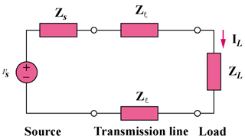

Figure 9.92
For Prob. 9.93.

